End User Documentation – MSNA Analysis Script
Draft: 22 August 2018
Contents
End User Documentation – MSNA Analysis Script 1
Brief Description – Content and Purpose of This Document 2
Toolkit Overview 2
Limitations of this Toolkit 3
Step 1: Downloading and setting up the toolkit 3
Downloading the Toolkit 3
Install R and R Studio 3
Installing relevant R packages 4
Step 2: Preparing your inputs 4
Prepare your analysis input file 4
Read me tab 5
Data tab 5
Kobo questions tab 5
Kobo choices tab 5
Choice ranks tab 5
Parameters tab 5
Stratification_samplingframe tab 6
Cluster_samplingframe tab 6
Composite_indicators tab 6
Analysis plan tab 7
Finalizing analysis input file 8
Step 3: Running Your R Script 8
Step 4: Using Your Outputs 9
Review of Outputs 9
Using the Disaggregations Master Table 10
Step 5: Troubleshooting 11

Brief Description – Content and Purpose of This Document

Toolkit Overview
If you are reading this, then you have been tasked with analyzing complex survey data for a Multi-Sectoral Needs Assessment (MSNA) or other assessment. REACH has developed an R-based toolkit to facilitate this analysis, and this handy guide will walk you the user through the steps needed to setup, run and use this toolkit.
The toolkit is designed for ease of use. The user only needs to prepare their inputs and describe their key composite and disaggregation indicators, and the program will automatically generate the desired results ready for joint analysis workshops and report writing. Key inputs needed include:
- Cleaned dataset in Kobo format (using xml names and headers)
- Survey tool xls form, choices list, and choices ranking (if applicable)
- Survey design indicators (strata, clusters and their names)
- Sampling information for population weighting purposes
- Composite indicator definitions with desired thresholds
- Analysis plan

The toolkit is comprised of a script in R and a toolbox in ARC, with most of the functions running behind the scenes (some files listed in ‘internal’ folder, which you do not need to pay attention to). Outputs from this script will include:
- Tables
- Charts
- Maps
- Heatmap
There are five overarching steps in the toolkit’s use that will be explained throughout this guide:
Step 1: Downloading and setting up the toolkit
Step 2: Preparing your inputs
Step 3: Running the R Script
Step 4: Using Your Outputs
Step 5: Troubleshooting

Limitations of this Toolkit
This toolkit will take a lot of the repetitive work out of preparing your survey results, but there are limitations to what the user should expect.
Toolkit will… | Toolkit Won’t…
Produce results that take into account survey design. | This program will not clean your data for you. Inputs must be cleaned beforehand, and the quality of the output depends on the quality of the inputs.  This program will not define your indicators and composite indicators for you. You must correctly construct the composite indicators. What you ask from it is what you will get.

Step 1: Downloading and setting up the toolkit

Downloading the Toolkit
- Request the most recent version of the toolkit from Martin Barner (martin.barner@impact-initiatives.org) or Eliora Henzler (eliora.henzler@impact-initiatives.org).
- Create a folder on your computer titled “XXX_MSNA_Analysis”. XXX should be the three letters for your country (e.g UGA = Uganda, NGA = Nigeria). Where this folder is located on your computer does not matter.
- The toolkit will be in a self-contained zip file. Unzip the contents of the zip file into the folder you created. The toolkit will not work if you try to work off of the unzipped folder.

Install R and R Studio
In order to run this script you should download and install the following:
R version 3.5.1 - For Windows, go to https://cran.r-project.org/bin/windows/base/ and click on the link to “Download R 3.5.1 for Windows” or “Download R 3.5.1 for Mac”
R Studio version 1.1.453 for Windows, from https://www.rstudio.com/products/rstudio/download/#download

Installing relevant R packages
Once both programs are installed, open R Studio. You will see several windows that serve different purposes. For now, just focus on and select the “Console” tab.
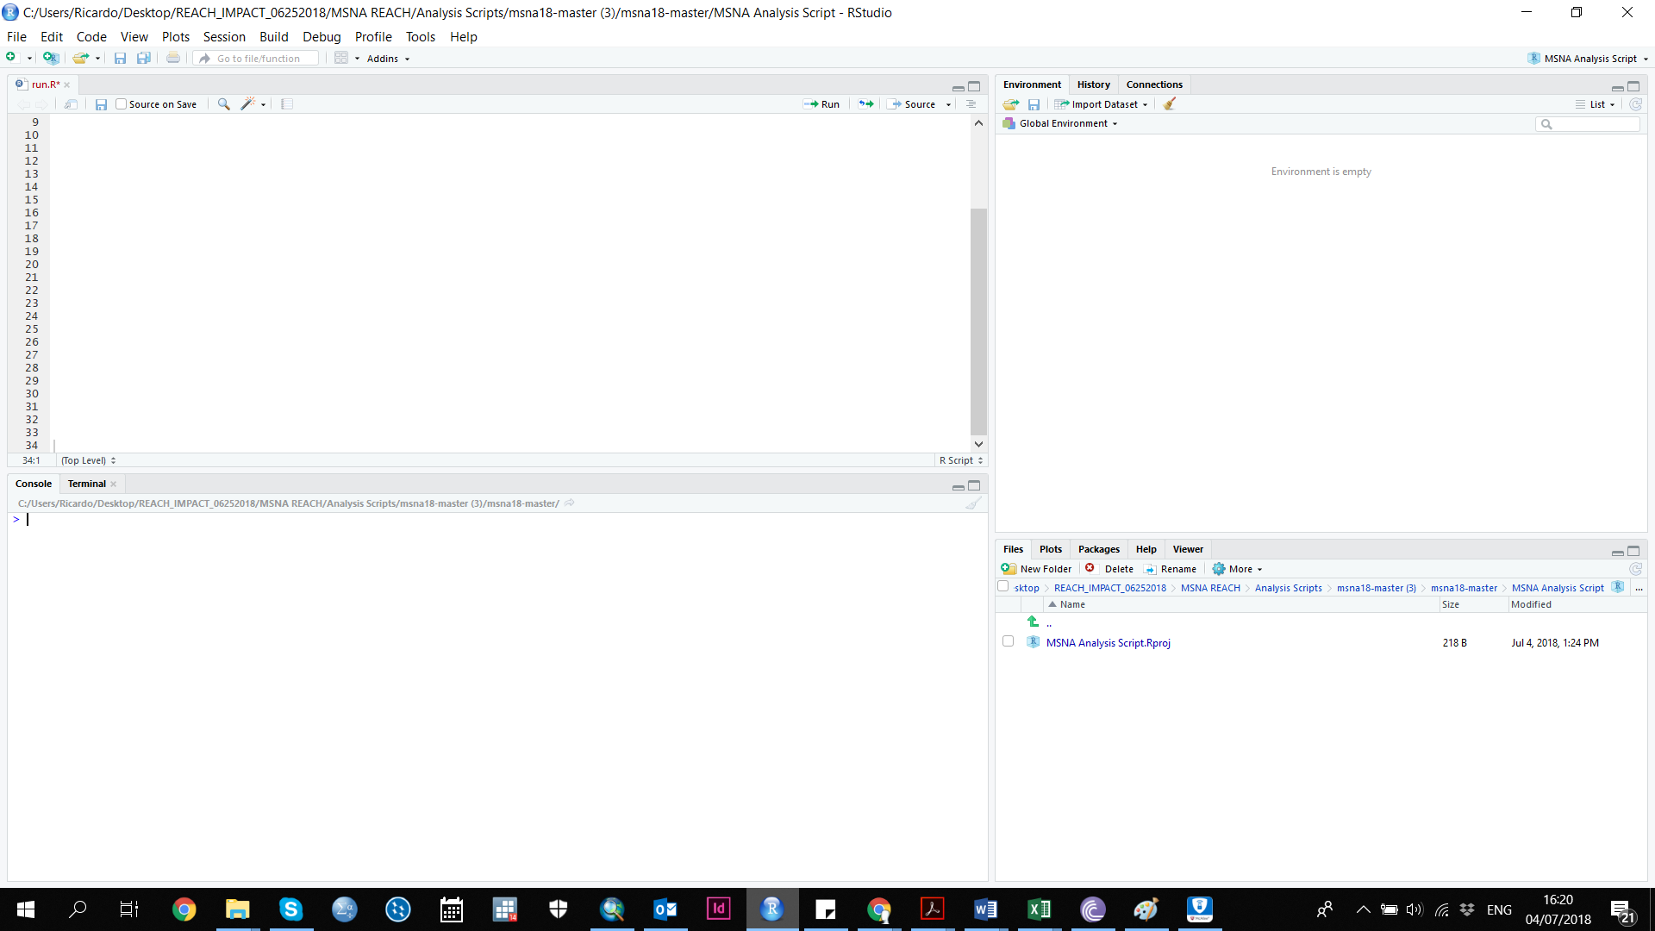
Console Tab and Window
R works with modules called “packages” which install new functions into the program. While this script will automatically install most packages you need, there are a three you can install manually before we begin. To install them, type the following line into the Console window and press enter to install. You must be connected to the internet. Input each one at a time and allow them to install.
- install.packages("rstudioapi")
- install.packages("magrittr")
- install.packages("dplyr")

Step 2: Preparing your inputs

Prepare your analysis input file
- The analysis input file encompasses all of the information needed for R to produce your analysis. The xls file consists of several components (in separate tabs):

  - Read me: This gives you instructions as how to fill out the analysis input file. When you are finished, you will need to click the “update analysis definition” button on this sheet as a final step before feeding into R.
  - Data: In this sheet, you will copy and paste your cleaned data set in Kobo format
  - Kobo questions: You will insert your Kobo tool in xls format in this sheet
  - Kobo choices: You will insert your Kobo choices from your tool in this sheet
  - Choice ranks: if you need your choices to show up in a particular order in your analysis outputs, you designate the order of your choices in this tab
  - Parameters: In this sheet, you identify the sampling strategy used, cluster variables, and which labels should be used in your outputs
  - Stratification sampling frame: if probability stratified or probability stratified cluster sampling was used, fill out this tab detailing the first strata and second strata variables, and the population figures used in the sampling frame
  - Cluster sampling frame: if probability cluster or probability stratified cluster sampling was used, fill out this tab detailing the first cluster (and second/third strata variables if applicable), and the population figures used in the sampling frame
  - Composite indicators: this tab includes all of the information used to define composite indicators, including your PIN calculations and thresholds.
  - Analysis Plan: this tab details your analysis plan and which variables at what levels should be analyzed by the scripts. You can also note which types of outputs (tables, charts, heatmaps, etc.) you need created for each variable analyzed.
- The following sections will cover the components of the analysis input file in detail so that it is clear what is required for each.

Read me tab
- The read me tab gives an overview of the analysis input file and is self-explanatory
- After filling out the analysis input file, you must return to the read me tab, click the “update analysis definition” button on the left, which prepares the file for R. This should only be done as a final step when the analysis input file is completed.

Data tab
- As you clean your data, be sure you have downloaded the it from Kobo using xml names and headers rather than labels. Do not select the option to include column groups.
- When you’ve finished cleaning data, make sure it is in the standard Kobo format (don’t delete columns, change headers, etc.)
- Paste your cleaned data set in standard Kobo format into the data tab in the analysis input file

Kobo questions tab
- Copy your tool directly from the xls form and paste it in the Kobo questions tab

Kobo choices tab
- Copy the choices in your tool directly from the xls form choices tab and paste it in the Kobo choices tab

Choice ranks tab
- This tab only applies if you want ordinal variables to be interpreted in a certain order in your outputs (i.e. bar charts sorted from largest to smallest).
- For each choice requiring a specific order, copy the list_name, name, and label from your choices tab, and indicate the rank (ordering) by adding integer numbers in the specified order in column E of the choice ranks tab.

Parameters tab
- In this tab, you will outline the basic parameters to identify which variables are related to your survey methodology. You will identify the sampling strategy and cluster variables used, as well as the labels to be used in your outputs.
- Sampling strategy: select the sampling methodology used in your assessment
- Cluster variables: select the variable used to identify which cluster the record belongs to. In most cases, cluster sampling is based on settlement, village, or another level of location. Choose which variable was used to determine the cluster.
- Questionnaire choices label column: In this column, designate which column (list_name, name, label, etc.) from your kobo choices list you want used as labels in your analysis outputs. If you want to create new label options to be used in your outputs, you can create another column in your kobo choices tab to identify the desired labels to be used.

Stratification_samplingframe tab
- You need to fill out this tab if you used probability stratified or probability stratified cluster sampling. Depending on your method, you may need to weight by sampling probability. In this tab, you outline your strata variables and the population figures used to determine your sampling so that the script can apply the appropriate weighting in the analysis. The variables will almost always be demographic information, such as district, state, respondent type, etc.
- In columns B and C, identify the strata variables used in your sampling frame. In column E, insert the population figures of each respective stratum.
- This information should be directly from your TOR or sampling frame, with some formatting adjustments. It is important to note that all spelling of your variables must be exactly as it appears in the data. Every combination (first strata variable, second strata variable) that appears in the dataset must be included here, or else the script will not include it in the analysis.

Cluster_samplingframe tab
- You need to fill out this tab if you used probability cluster or probability stratified cluster sampling. Depending on your method, you may need to weight by sampling probability. In this tab, you outline your cluster variables and the population figures used to determine your sampling so that the script can apply the appropriate weighting in the analysis. The cluster variables used are typically by settlement, but may be other levels of location
- In columns B (and C if a second cluster variable was used), identify the cluster variables used in your sampling frame. In column E, insert the population figures used.
- This information should be directly from your TOR or sampling frame, with some formatting adjustments. It is important to note that all spelling of your variables must be exactly as it appears in the data. Every combination (first cluster variable, second cluster variable) that appears in the dataset must be included here, or else the script will not include it in the analysis.

Composite_indicators tab
In this tab, you will define all of the composite indicators, or indicators that are constructed from multiple questions. You will need to determine the following for each composite indicator:
- The variable names of all questions that will contribute to the composite indicator (input variables)
- The values of each of those input variables which will contribute to the composite indicator
- The weight of each value that will contribute to the composite indicator
- Note: these attributes (variable, value, weight) will typically be developed in coordination with the clusters/sectors through the joint analysis process. This is where PIN definitions and thresholds come into play.
First, let’s understand the structure of the table you see under the composite_indicators tab.
weight
This column indicates the weight applied to the composite variable, if this value is present.
value
This column should contain the values of the input variable (exactly as appears in data). Any value of that variable not specified here will be assumed to not contribute to the composite variable.
New.var.name
This column should contain a name for your new composite variable. Each white cell under each blue section should have the EXACT SAME NAME.
var
This column should contain the name the input variable (exactly as it appears in data) for this light blue section.
condition
This column sets a condition (any, equal, less, greater all, skipped, etc.) for the value in the next column. If setting multiple conditions for the same variable, this goes in order and is overwritten by the first condition listed.

Each DARK BLUE ROW is for 1 composite indicator. No information will be included on this row, but all the rows underneath it up for will contain the information needed for 1 composite indicator. Each composite indicator will have one large

Each LIGHT BLUE ROW is for 1 “input variable” that will be used to create that composite indicator.

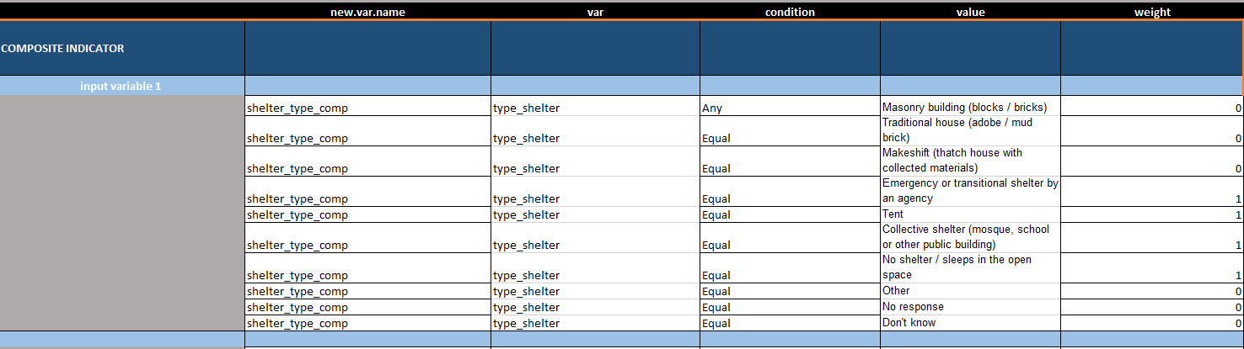
Each WHITE ROW is for 1 value of the “input variable” that will be used to create the composite variable. This row will tell us how that value will contribute to the composite indicator.

For each composite indicator you want to define, you will need to COPY and PASTE a new block of rows to the bottom of the table, and redefine the composite indicator, input variables, values and weights.
You can make a composite indicator based on previous composite indicators but they are produced in order from top to bottom. For example, if you want to code food_PIN based on food consumption score and self_assessment you need to build those two composite indicator blocks above the food_PIN.
Note: If you have created new composite indicators in the composite_indicator tab that should be included in your outputs, you must add the new variables (composite indicator) to the Kobo questionnaire and Kobo choices tabs.

Analysis plan tab
- This tab details your analysis plan and which variables at what levels should be analyzed by the scripts. You can also note which types of outputs (tables, charts, heatmaps, etc.) you need created for each variable analyzed.
- Repeat for column:
- Disaggregate by:
- Variable: choose the variable you want analyzed
  - There is a possibility to run analyze all variables by inputted [[ALL]]. Note: this only includes variables from the Kobo questionnaire that are select one, select multiple, or numerical types questions. Be aware that this could create thousands of outputs depending on the disaggregation. It is better to identify which specific indicators to analyze rather than including all in the analysis plan.
  - Note: If you want your composite indicators (PINs) shown in the outputs, you need to add the new variable (composite indicator) into your kobo questionnaire in the respective tab.

Finalizing analysis input file
- Once you have inserted all of the required information in each of these components, you are almost done preparing your inputs – congratulations!
- After filling out the analysis input file, you must return to the read me tab, click the “update analysis definition” button on the left, which prepares the file for R. This should only be done as a final step when the analysis input file is completed. Be sure that the analysis input file is saved in the input folder, or else R will not be able to find the file.
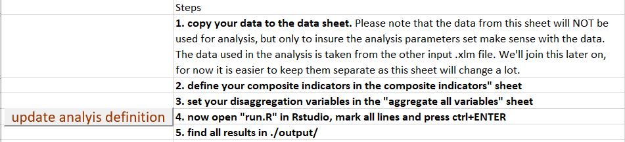

Step 3: Running Your R Script

Running the R script is quick and easy as compared to all of the work you’ve done to prepare your analysis input components. Within the folder you created “XXX_MSNA_Analysis” which contains the toolkit, you will see a file titled run.R. This is the master script of code which will run the entire analysis script.
Open this file with R Studio (you must also have R installed on your computer, but it is not necessary to have R open at this step). You will see a few lines of code under a window titled “run.R”.
Select all the lines of code. In the top right of that window, click on the button “Run,” or with all text highlighted, press command enter.
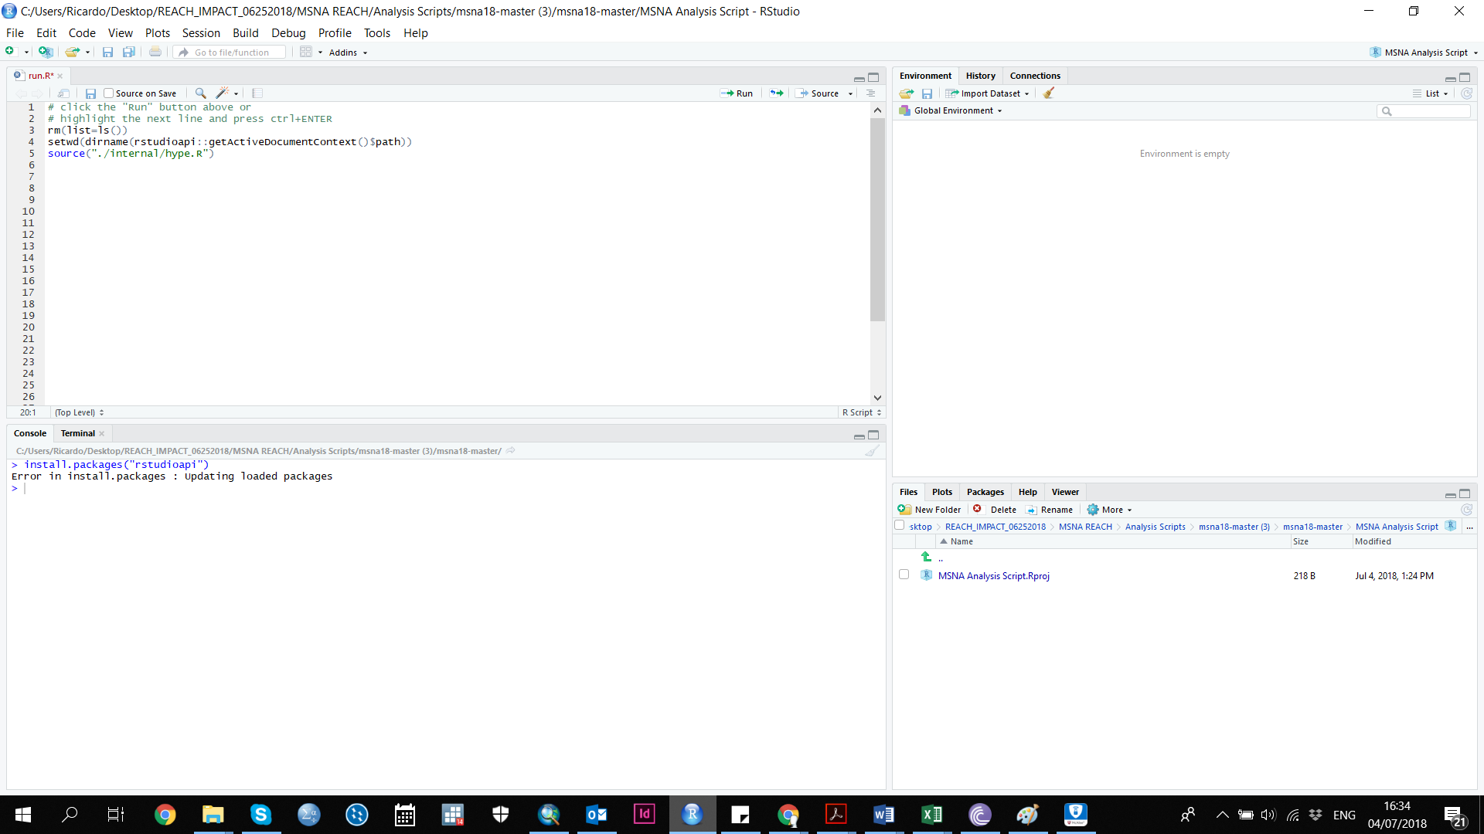
The first time you run the script in R studio, it will take longer than subsequent times. The program needs time to download all software and packages, so be patient. For the first time running the scripts, make sure you are connected to the internet.
Receiving an error
- If the script fails, you will most likely receive an error message that tells you exactly why it failed and what the issues are. There will also be information included on how to solve the error. The error is likely due to an issue with a component of your analysis input file.
- The script has been developed to anticipate errors and give you a message with more information. If you aren’t familiar with R, the message may look like gibberish. Read through the gibberish-looking text, and there will be a few sentences explaining the error. Don’t be intimidated by the gibberish text, there is a useful hint in there somewhere!

Step 4: Using Your Outputs

Review of Outputs
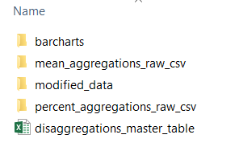
After running the run.R script, your outputs should now appear in the XXX_MSNA_Analysis/output folder. Other folders will be created as well with intermediary files for other outputs only. Please find below a description of each of the different outputs:

Contents of output folder after run.R script is run
Output | Description
Barcharts folder | Barcharts with confidence intervals produced for each question/variable against selected disaggregation variables. JPG format.
Modified data | Your dataset returned with new columns added for the composite indicators. CSV format.
Disaggregations_master_table | Spreadsheet where you can view results of single indicators and disaggregation variables. XLSX format.
Mean_aggregations_raw_csv | Intermediary files for other outputs. Don’t be concerned with these.
Percent_aggregation_raw_csv | Intermediary files for other outputs. Don’t be concerned with these.
Datamerge | The datamerge file is produced so that can use it for InDesign. This is directly linked to your analysis plan, so any analyzed variables needed for factsheets must be listed in the analysis plan.
Error file | If you’ve received an error message in R as to why running the script failed, you may see an error file with information about what went wrong. For example, you may have a file showing issues with clusters, if that was the reason the script failed to run.

Using the Disaggregations Master Table
The disaggregations master table will allow you to select a question/variable and then disaggregate the results by another indicator of your choice. Simply select your question/variable under “show variable” and select your disaggregation variable under “disaggregate by”. Results for categorical variables are presented as proportions and numeric variables as means. Note: each time you open the file, make sure you go to the data tab, click refresh all, and link to the relevant cvs file (likely something called table_long.csv). Right click the pivot table and click refresh.
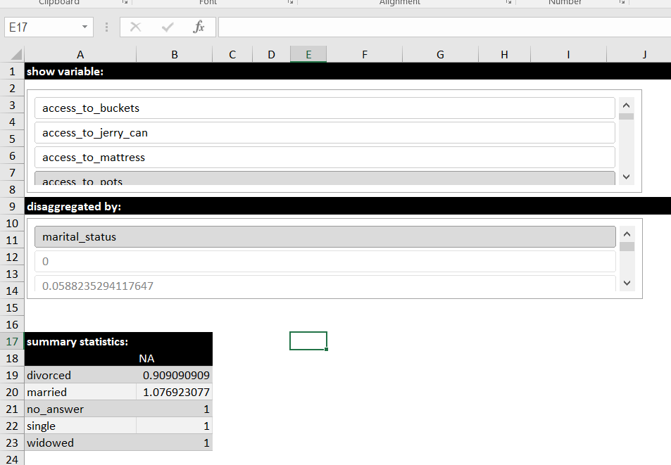

Step 5: Troubleshooting

To be added by Martin/Eliora detailing the various error messages one could receive if the script fails to run.

WOHOOOOOO

